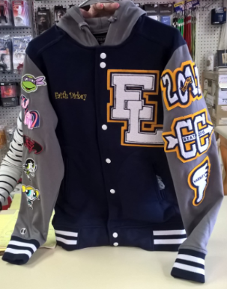

Additional styles & colors are available. Prices may vary.

$150

Letterman Fleece Jacket

Pricing includes embroidered name, school letter(s), & up to three 4” patches

*Additional Patches $10 ea.

**50% deposit on all orders

Bringing Team Spirit Back!

To order your custom letterman jacket contact:

Shurrod Dickey

Phone: 678.887.1512

E-mail: [coachescorner05@hotmail.com](mailto:coachescorner05@hotmail.com)

**Website:** [www.coachescorner05.com](http://www.coachescorner05.com)

## Coaches Corner AAD

# LETTERMAN JACKETS